**POWER BI ASSIGNMENT – 1**

**Use Case -** Connecting a file using Power Bi Desktop and formatting the file.

**Source –** Sky Transport.

Analytics- Create a new power Bi file, load the excel workbook containing a list of transport data.

**Solution:**

**Step-1.** From Home tab , Click on get data and select Excel then choose Sky Transport Corp. file from the folder which you have saved

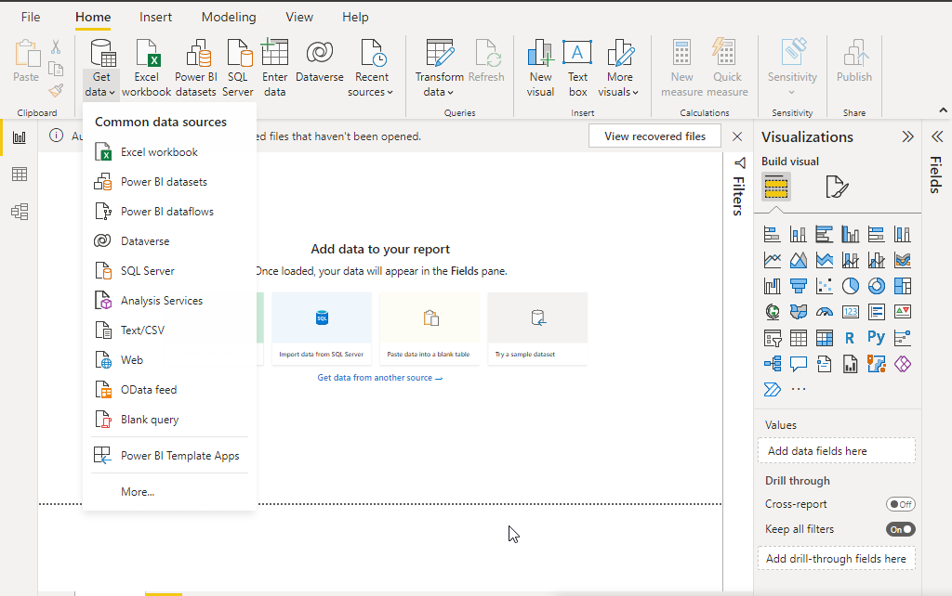

Q2. Create a new Power Bi file, and load the Excel workbook containing a list of the Transport Data.

**Step-2.** Once you selected the file it goes to Navigator Window, tick mark the worksheet check box then click on Transform Data

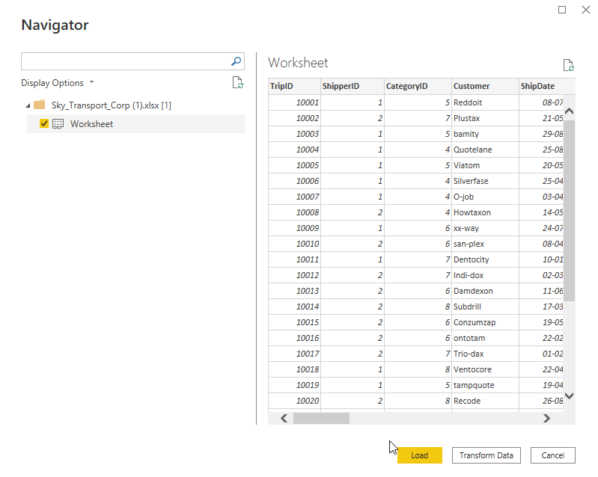

**Requirement:**

1. You should hide the Category ID and Origin State.

**Step-3.** Go to Category ID and Origin State by right click and select the Hide Button.

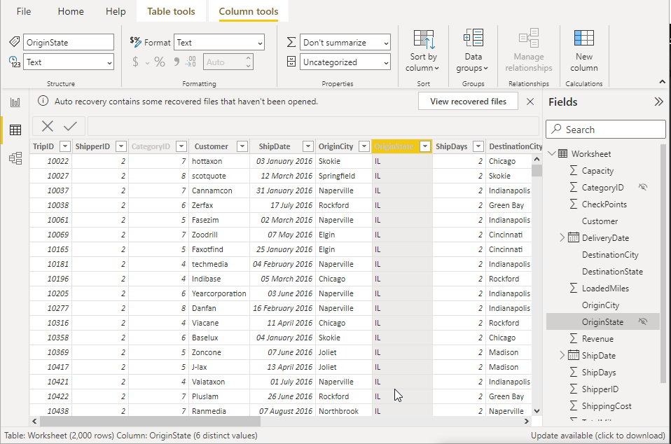

1. Create a table showing by Customer Name
2. Revenue
3. Total Miles
4. Trip Type

**Step-4.** Go to Report View Mode, choose table from Visualizations option. Create a table that contain customer name with Revenue, Total Miles & Trip Type. Drag these 3 fields into the values.

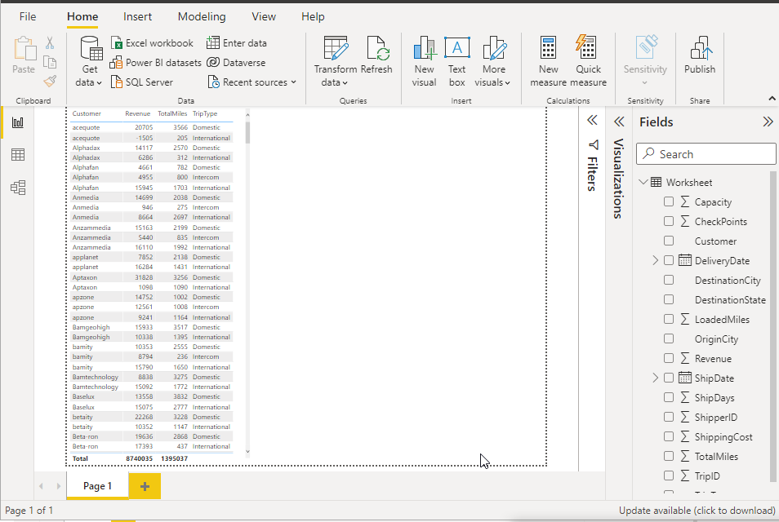

1. Summarize the Revenue & Total Miles

**Step-5.** Format the Detail and summarizing the Revenue and total miles.

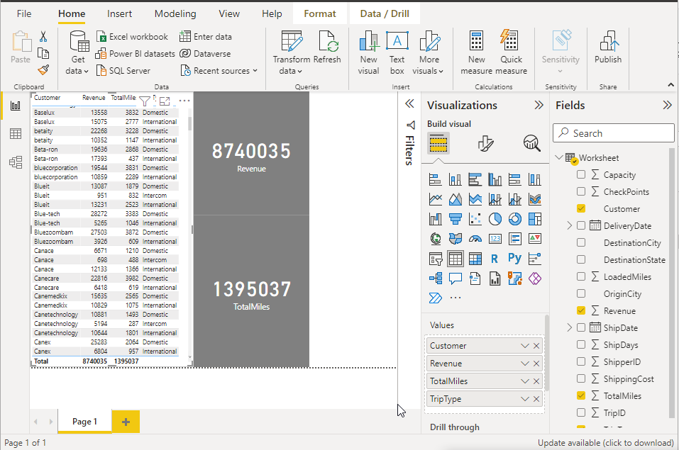

1. Save this Power BI file with the name Sky Data

Step-6. Saving Power BI file with Sky Data name

